

**Mission 6:**

**Remix**

**Student Workbook**





**Press those buttons!**

This assignment will let you be creative and come up with your own program for the   
CodeX to run.

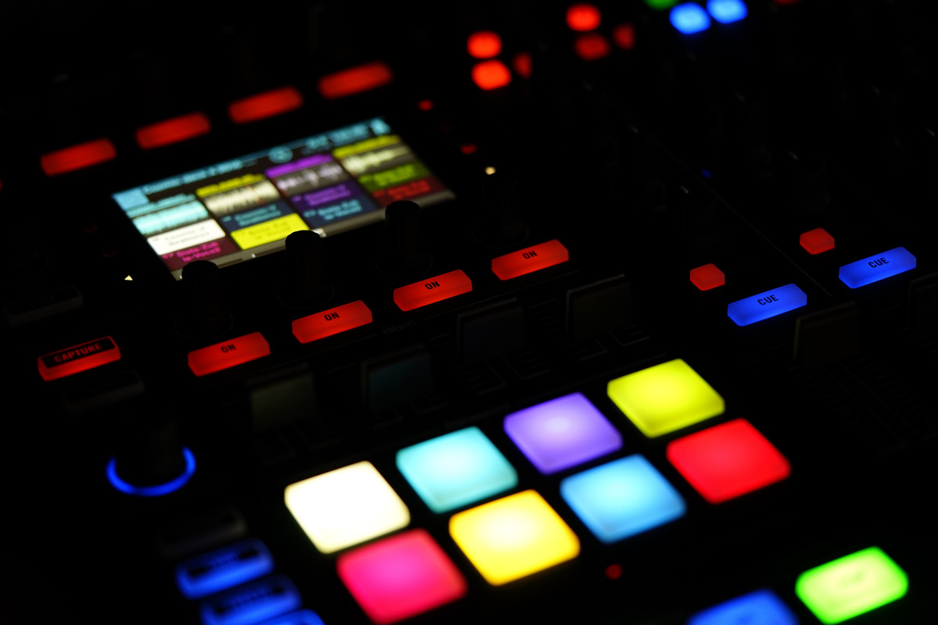

Go to the Mission 6 Remix Log and fill out the Pre-Remix preparation.



**Time for a project remix**

A remix can be:

* A new program created by adding new code to a program you already created
* You can combine parts of two or more programs in a remix
* Use a similar idea in a different way

**Creating a remix will let you:**

* Master the skills and concepts practiced in the mission
* Be creative
* Remember code from earlier programs and missions
* Work with your peers
* Design an original program and write the code all on your own

**Step #1: Review the mission**

* Review your programs from Mission 2 through 6
  + What do the programs do?
  + What skills were used or concepts learned?

**DO THIS:**

* Open your project from Mission 6 -   
   Heart2
* Review what the program does
* Review the programming concepts and   
   skills you learned
* Fill out the information in the remix log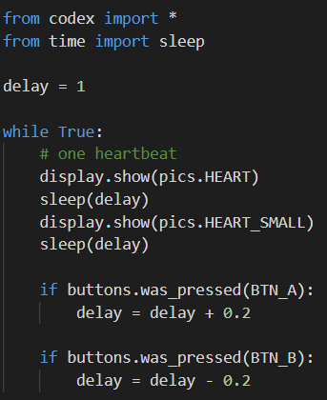

**Step #2: Brainstorm ideas**

* Read through remix suggestions.
  + Eight ideas are on the next pages. You can use any of these ideas or come up with your own.
  + You can combine any parts of the suggestions into your remix.
* Use your creativity to come up with your own idea for a project.
* Decide with your partner what project you will do.



**Mild Remix #1A**

Make one or more pixels flash on and off, instead of an image on the screen.

[Video of Remix #1A](https://youtu.be/8BszMy4_mbk)



**Mild Remix #1B**

Add flashing pixels to the heartbeat. You have one, two or all of the pixels flashing during the heartbeat.

[Video of Remix #1B](https://youtu.be/0ZY2qgx3ERI)



**Medium Remix #2A**

Add another if statement for a different button press that will break out of the loop to stop the program.

[Video of Remix #2A](https://youtu.be/50Bsnr0cOqw)



**Medium Remix #2B**

Change the flashing image to pixels that roll, turning on one pixel at a time. One sequence will be pixel 0, then pixel 1, then pixel 2, and then pixel 3. Repeat the sequence in a loop, with the option to speed up or slow down.

[Video of Remix #2B](https://youtu.be/k9VvgznuuGg)



**Medium Remix #2C**

Add two pitch sounds to the heartbeat, one for each image. Use the delay variable in the pitch statement instead of a sleep statement  
 Example: **audio.pitch(440, delay)**

Video of Remix #2C



**Spicy Remix #3A**

Add code that will prevent the runtime error. Remember: the error happens when the delay is below 0. How can you make sure this doesn’t happen?

[Video of Remix #3A](https://youtu.be/dIe1z1SX6_w)



**Spicy Remix #3B**

Change the flashing image to a left (west) or right (east) arrow. Use different button presses to change from one image to the other.

[Video of Remix #3B](https://youtu.be/draJwpZ5W0s)



**Extra Spicy Remix #4**

Add a menu that explains what each button press will do, and another break to hold the menu until they want to start. Also, include an ending message. If you include flashing pixels, add another variable for the color.

[Video of Remix #4](https://youtu.be/5sNVTN766tk) / [Remix with flashing pixels](https://youtu.be/iLqC-29p6GI)

**DO THIS:**

* Decide with your partner what project you   
   will do
* Fill out the information in the Mission 6 Remix   
   Log for **Step #2**

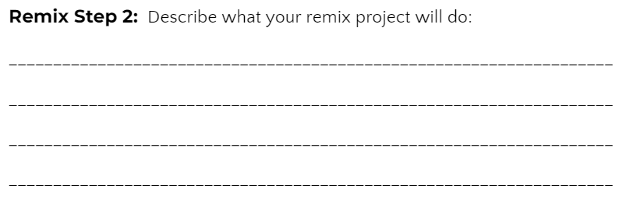

**Step #3: Make a plan**

Now that you have an idea for your remix, you need a plan.

* What variables will you need?
* What images will you display?
* What pixels will you turn on/off?
* What buttons will you program?
* What will each button do?

**DO THIS:**

* 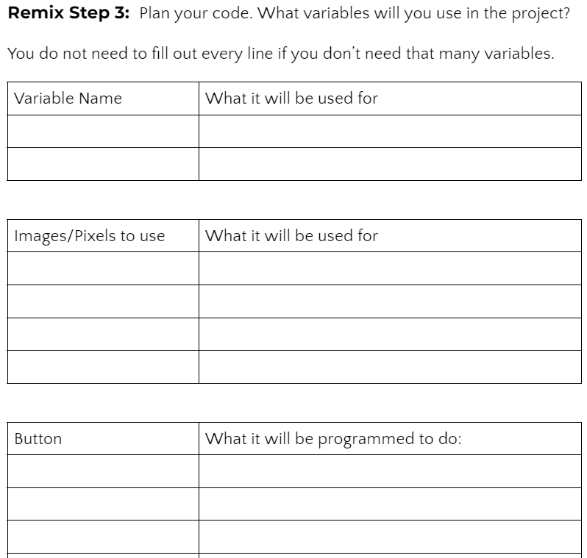Fill out the information in the Mission 6 Remix   
   Log for **Step #3**

**Step #4: Code your project**

* **IMPORTANT:** In CodeSpace, go to the sandbox: 
* You can leave any program open, including **Heart2**, and use it as a guide



**DO THIS:**

* Start with a new file and give it a descriptive   
   name (**Remix6**)
* Import your modules
* Define your variables
* Write your code, testing frequently

**Reminders!**

* Don’t try to write all the code at one time
* Mistakes happen, so find them early
* Type just a few lines of code and then run the program
* If there is an error, fix it before continuing
* Use the debugger and your other programs for help

**Step #5: Documentation**

You should always make your code readable and easy to follow.



**DO THIS:**

* + - * Add blank lines where needed to divide sections of code
      * Add a comment at the top with your name and the name of the program
      * Add a few more comments to sections of your code that explain what they do

**Step #5: Get feedback**

Getting feedback and reflecting on your code can help you make the program even better.



**DO THIS:**

* Show your code to another student
* Have him/her fill out the feedback form on your Mission 6 Remix Log
* Give yourself some feedback
* Is there something you want to change or   
  improve or add?
* Fill out the feedback form on your Mission 6   
  Remix Log

**Modify your code to make your project even better**

**Congratulations!**

Now you have your own remix!   
Great job! Share your project with   
your friends.

By completing this remix you have:

* learned more about programming
* used skills and concepts from the missions
* been thinking!
* and problem solving
* and much more!
* 

**DO THIS:**

* Complete the Mission 6 Remix Log
* Don’t forget to clear your CodeX by running your **Clear** program